Portal for ArcGIS 10.3 / 10.3.1
Installing Custon Widget for use in Web App Builder
Overview

This document will walk you through the steps required to add custom widgets to your Portal for ArcGIS 10.3 / 10.3.1 deployment. Please note that these steps will not work with ArcGIS Online and may differ slightly with previous versions of Portal for ArcGIS (v.10.2.2 and earlier).

Prerequisites:
- Portal for ArcGIS 10.3 / 10.3.1
- Custom Web App Builder Widget
To create a custom widget that is compatible with the Web App Builder, please follow the steps in the following document: https://developers.arcgis.com/web-appbuilder/sample-code/create-custom-in-panel-widget.htm
- Edit permissions on the Portal for ArcGIS install directory and sub directories

Step 1
Copy custom widget to the following two directories:
"<install_location>\ArcGIS\Portal\apps\webappbuilder\stemapp\widgets\"
"<install_location>\ArcGIS\Portal\apps\webappviewer\widgets\"

The default locations are:
"C:\Program Files\ArcGIS\Portal\apps\webappbuilder\stemapp\widgets"
"C:\Program Files\ArcGIS\Portal\apps\webappviewer\widgets\"

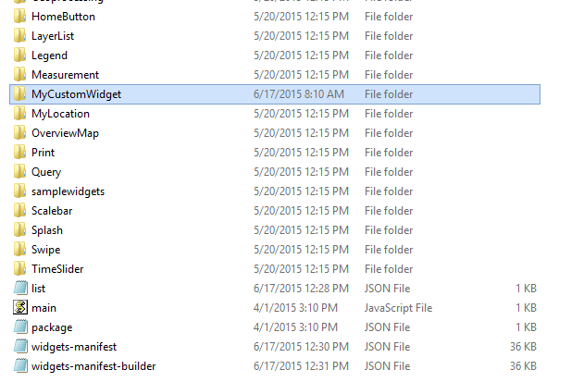

Step 2
Make the following changes to the "config.json" file in the following locations:
"<install_location>\ArcGIS\Portal\apps\webappbuilder\stemapp\"
"<install_location>\ArcGIS\Portal\apps\webappviewer\"

- Under the "_buildInfo" section, set "widgetManifestsMerged": true
- Add custom widget to the "WidgetPool"\"widgets"

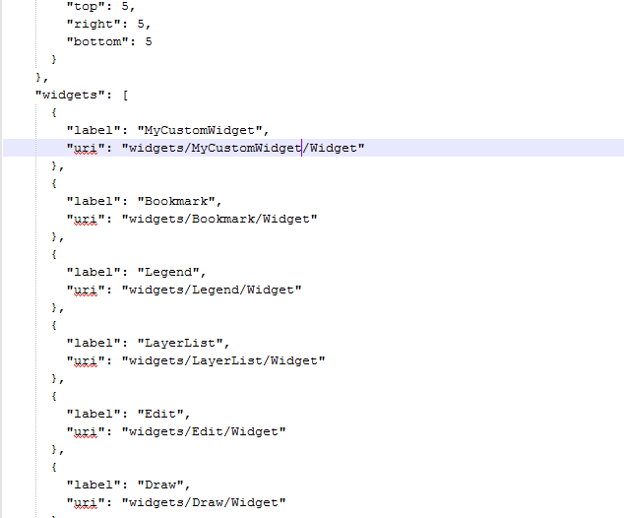

Step 3

Add your widget's manifest to the widget manifest file ("widgets-manifest-builder.json")
"<install_location>\ArcGIS\Portal\apps\webappbuilder\stemapp\widgets\"
"<install_location>\ArcGIS\Portal\apps\webappviewer\widgets\"

Example of a menifest:
"widgets/MyCustomWidget/Widget": {
"name": "MyCustomWidget",
"2D": true,
"3D": false,
"platform": "HTML",
"version": "1.0",
"wabVersion": "1.0",
"author": "Esri South Africa",
"description": "My Custom Widget",
"copyright": "Esri South Africa",
"license": "http://www.apache.org/licenses/LICENSE-2.0",
"properties": {
"inPanel":true,
"hasLocale": false,
"hasStyle":true,
"hasConfig":true,
"hasUIFile":true,
"hasSettingPage":false,
"hasSettingUIFile":false,
"hasSettingLocale":false,
"hasSettingStyle":false,
"IsController":false
},
"category": "widget",
"i18nLabels": {
"defaultLabel": "My Custom Widget"
}
},

Step 4 & 5

Step 5
Restart your Portal for ArcGIS service

Step 6
Create a new Web Application and add your custom widget

